A Review on Various Edge Detection Methods used in Digital Image Processing for Feature Detection and Extraction

Rajni Bala¹ ,Kulwinder Singh²,Harleen Kaur³,Ashu Jaggi⁴
^{1,3,4}Department of Electronics & Communication Engineering
²Assistant Professor and Head, Gulzar Group of Institutes, Khanna (Punjab)
^{1,3,4}Assistant Professor, Gulzar Group of Institutes, Khanna (Punjab)
rajnibalabala@rediffmail.com ^{[1]},kulwinder8787@gmail.com^{[2]},harleenkaurdhanda@gmail.com^{[3]}, ashujaggi@gmail.com^{[4]}

Abstract- Edge detection is a fundamental tool in image processing and computer vision particularly in the areas of feature detection and feature extraction which aim at identifying points in a digital image at which the image brightness changes sharply or, more formally, has discontinuities. Edge detection is one of the fundamental issues of digital image. In this paper, mathematical morphology method and several classical edge detection operators are reviewed. This paper provides methods for edge detection: Mathematical Morphology, Sobel Operator, Prewitt Operator, Simple Edge tool and Advance Edge tool which summaries relatively good image edge detection methods.
Keywords- edge detection, mathematical morphology, sobel operator, prewitt operator, simple edge tool, advance edge tool.

I INTRODUCTION

Edge detection is a fundamental tool used in most image processing applications to obtain information from the frames as feature extraction and object segmentation. This process detects outlines of an object and boundaries between objects and the background in the image. Edge detection[2] techniques transform images to edge images benefiting from the changes of grey tones in the images. Edges are the sign of lack of continuity, and ending. Edge detection is one of the methods based on edge segmentation. There is always edge between two adjacent regions with different grey level. Edge detection is a problem of fundamental importance in image analysis. In typical images, edges characterize object boundaries and are therefore useful for segmentation, registration, and identification of objects in a scene.
At present, there are many ways have been developed for edge detection, such as: mathematical morphology, sobel operator, simple edge tool, advance edge tool.

II. MATHEMATICAL MORPHOLOGY
Mathematical morphology (MM) is a theory and technique for the analysis and processing of geometrical structures, based on set theory. Morphological operations could enhance contrast, eliminate noise, refinement and skeleton extraction, region filling and object extraction, boundary extraction and so on. The morphological use a certain form of structuring elements to measure and extract the image correspond shape, achieve the image analysis and identification purposes. SE can be of varying shapes and size according to our requirements. SE is a shape, used to probe or interact with a given image.
Basic operations of MM[1] is dilation, erosion, opening, closing. These basic operations can
also be combined into a variety of morphological methods to calculation.
Dilation is the operation that grows or thickens objects in an image. Erosion shrinks or thins objects in an image.
In mathematical morphology, Opening is the dilation of the erosion of a set A by a structuring element B:

where and denote erosion and dilation, respectively.

In mathematical morphology, the closing of a set binary image A by a structuring element B is the erosion of the dilation of that set,

The key of Image edge detection based on morphology is:
how to combined morphological edge detection operator use the morphological structure of various basic operations, and
how to select the structural elements to better solve the edge detection accuracy and the coordination of anti-noise performance. Binary image of the object recognition rely on to determine whether the adjacent pixels in the image are 4 connected or 8 connected.
MATLAB often use two kinds of connections: 4-connect and 8-connect. In the 4-connect agreed approach, only the vertical
direction of the four adjacent
Pixels may be connected; but in the 8-connect agreed approach, users expect access to the 8 pixels adjacent
pixels are the pixels may be connected.

III. SOBEL OPERATOR
The Sobel operator is used in image processing, particularly within edge detection algorithms. Technically, it is a discrete differentiation operator, computing an approximation of the gradient of the image intensity function. At each point in the image, the result of the Sobel operator is either the corresponding gradient vector or the norm of this vector. The Sobel operator[2] is based on convolving the image with a small, separable, and integer valued filter in horizontal and vertical direction and is therefore relatively inexpensive in terms of computations. On the other hand, the gradient approximation which it produces is relatively crude, in particular for high frequency variations in the image. The operator calculates the gradient of the image intensity at each point, giving the direction of the largest possible increase from light to dark and the rate of change in that direction. The result therefore shows how "abruptly" or "smoothly" the image changes at that point, and therefore how likely it is that that part of the image represents an edge, as well as how that edge is likely to be oriented. In practice likelihood of an edge calculation is more reliable and easier to interpret than the direction calculation. The gradient of the image intensity function at each image point is a 2D vector with the components given by the derivatives in the horizontal and vertical directions.
The operator uses two 3×3 kernels which are convolved with the original image to calculate approximations of the derivatives - one for horizontal changes, and one for vertical. If we define A as the source image, and G_{x} and G_{y} are two images which at each point contain the horizontal and vertical derivative approximations, the computations are as follows:

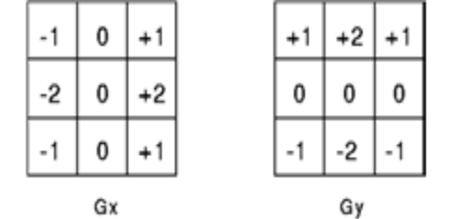
Horizontal Vertical
Figure-1
IV PREWITT OPERATOR
This differential Operator[4] is similar to Sobel Operator. The operator uses two 3×3 kernels which are convolved with the original image to calculate approximations of the derivatives. one for horizontal changes, and one for vertical. The Prewitt Operator is slightly simpler to implement computationally than the Sobel Operator, but it tends to produce some noisier results. Kernel Operators for Prewitt is given in the following figure.

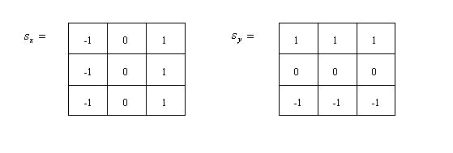
Horizontal Vertical

Figure-2

V SIMPLE EDGE TOOL & ADVANCED EDGE TOOL

These tools are used to detect the edges from an image by using NI Vision Assistant .
Firstly, edge tool is selected from Edge Detector List. From the list we can select Simple Edge Tool or Advanced Edge Tool[6]. Now, in image click and drag to select a path along which to search for edges. Vision Assistant displays line profile describing the path and list the number of edges found along the path.
Line Profile displays the grayscale distribution along a line of pixels in an image.
We can specify which edges we are looking for with the help of look for command. Kernel size can also be selected by user choice. e.g.(3,5,7) etc. Threshold value is selected according to the needs of the users.
The advantage of this tool is that computational complexity is very less and speed is fast.

VI RESULTS & DISCUSSIONS
Experiment was carried out in MATLAB and last method is simulated in NI Vision Assistant. From the result can be found that the mathematical morphological method can extract much better the edge of an object. But the noise points will be wrongly detected for the image edge points because of the noise. So, in practice, the noise should be filtered firstly in order to reduce the noise
impact. Because the noise can not be completely removed, so the edge pixels will be isolated or exist part of the small pieces of continuous.
It was also observed that Simple edge tool and Advanced Edge tool in NI Vision Assistant are less complex.
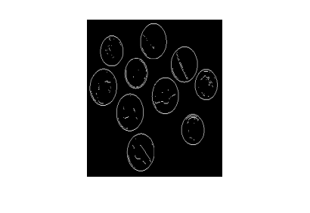
Fig. 3: Sobel Edge Detection

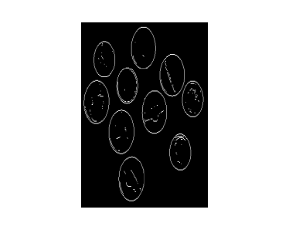
Fig. 4: Prewitt Edge Detection

VII CONCLUSION

In practice, choosing a suitable method for image edge extraction should base on the specific environmental conditions. Although there are many classical detection methods in the edge detection, but each have respective advantages and disadvantages, so should select the appropriate algorithm based on the requirements and conditions. We need to do is to choose the best algorithm so that the error is minimum. The Prewitt Operator is simpler but it produces somewhat noisier results. Sobel Operator is most commonly used edge detection Operator.

REFERENCES

[1] Hui Yang, Jiwu Zhang. “Mathematical Morphology in Edge Detection Application,” Journal of Liaoning University (Natural Science Edition), vol.32, no.1, pp. 50-53, 2005.
[2] Zheng et al., ‘‘ Edge Detection Methods in Digital Image Processing,’’ The 5th International Conference on Computer Science & Education Hefei, China. August 24–27, 2010.
[3] The MathWorks, Inc. Image Processing Toolbox 6 User Guide. 2009.
[4] R. C. Gonzalez and R. E. Woods, Digital Image Processing,Second Edition, Pearson Education Asia, 2002.
[5] Zuwena et al., ‘‘Comparison of Real Time DSP-Based Edge Detection Techniques for License Plate Detection,’’ 2010 Sixth International Conference on Information Assurance and Security.
[6] National Instruments Vision Assistant , User Guide.2009.

